|  |
| --- |
| 🏷️ This is provided only as a sample with no guarantees or warranties. Please adapt & customize to your specific business needs. |

**0️⃣ Pre-Requisite**

Build Your Own Copilot Dashboard - Sample

1. Run a new, custom **Person Query (**[**link**](https://analysis.insights.viva.office.com/analyst/analysis/personQuery)**)**
   1. Under **Metrics**:
      1. Add all “**Microsoft 365 Copilot**” metrics
      2. Add “**Meeting Hours**” and “**Meetings**” metrics
   2. Under **Attributes**:
      1. Add: “**Organization**” and “**Function Type**”

|  |
| --- |
| 🏷️ **Note**: If you’re using **Entra ID** and not an org data file as your source for attributes, you won’t have Function Type as an option. Please proceed with adding the attributes that you would like, make note of them, and then later in this guide, there will be a step where in PowerBI you can update the query to match the columns/fields/attributes that you would like to use. |

* 1. Once your query results are ready, download the CSV file.

✅ **Step-by-step Guide to Setup the PowerBI Dashboard**

1. **Opening the PowerBI Project:**
   1. Double-click the **PowerBI** file with the extension **.pbix**
2. **Applying the Data Source:**
   1. By default, you’ll see the sample data that we’ve included.
   2. To change it to your data, click on “**Transform Data**”.
   3. Select the “**Person Query Export**” table > Under Home, click “**Advanced Editor**”
   4. Next, you’ll need to decide how you want to connect PBI to your data, choose one of the following scenarios.
   5. **Scenario A (Default):** Connect PBI using the **local copy of the Person Query export in CSV** format.
      1. Update the source to point to the location of your Person Query Export (CSV) file.
      2. A screenshot of a computer

         Description automatically generated
   6. **Scenario B**: Connect PBI **directly to the query in Advanced Insights**. This way you don’t have to download the CSV file on a current basis.
      1. Uncomment and replace the “**Source =** “ line with your details.
      2. You’ll need to update this line with your **Partition Identifier** & **Query Identifier**.

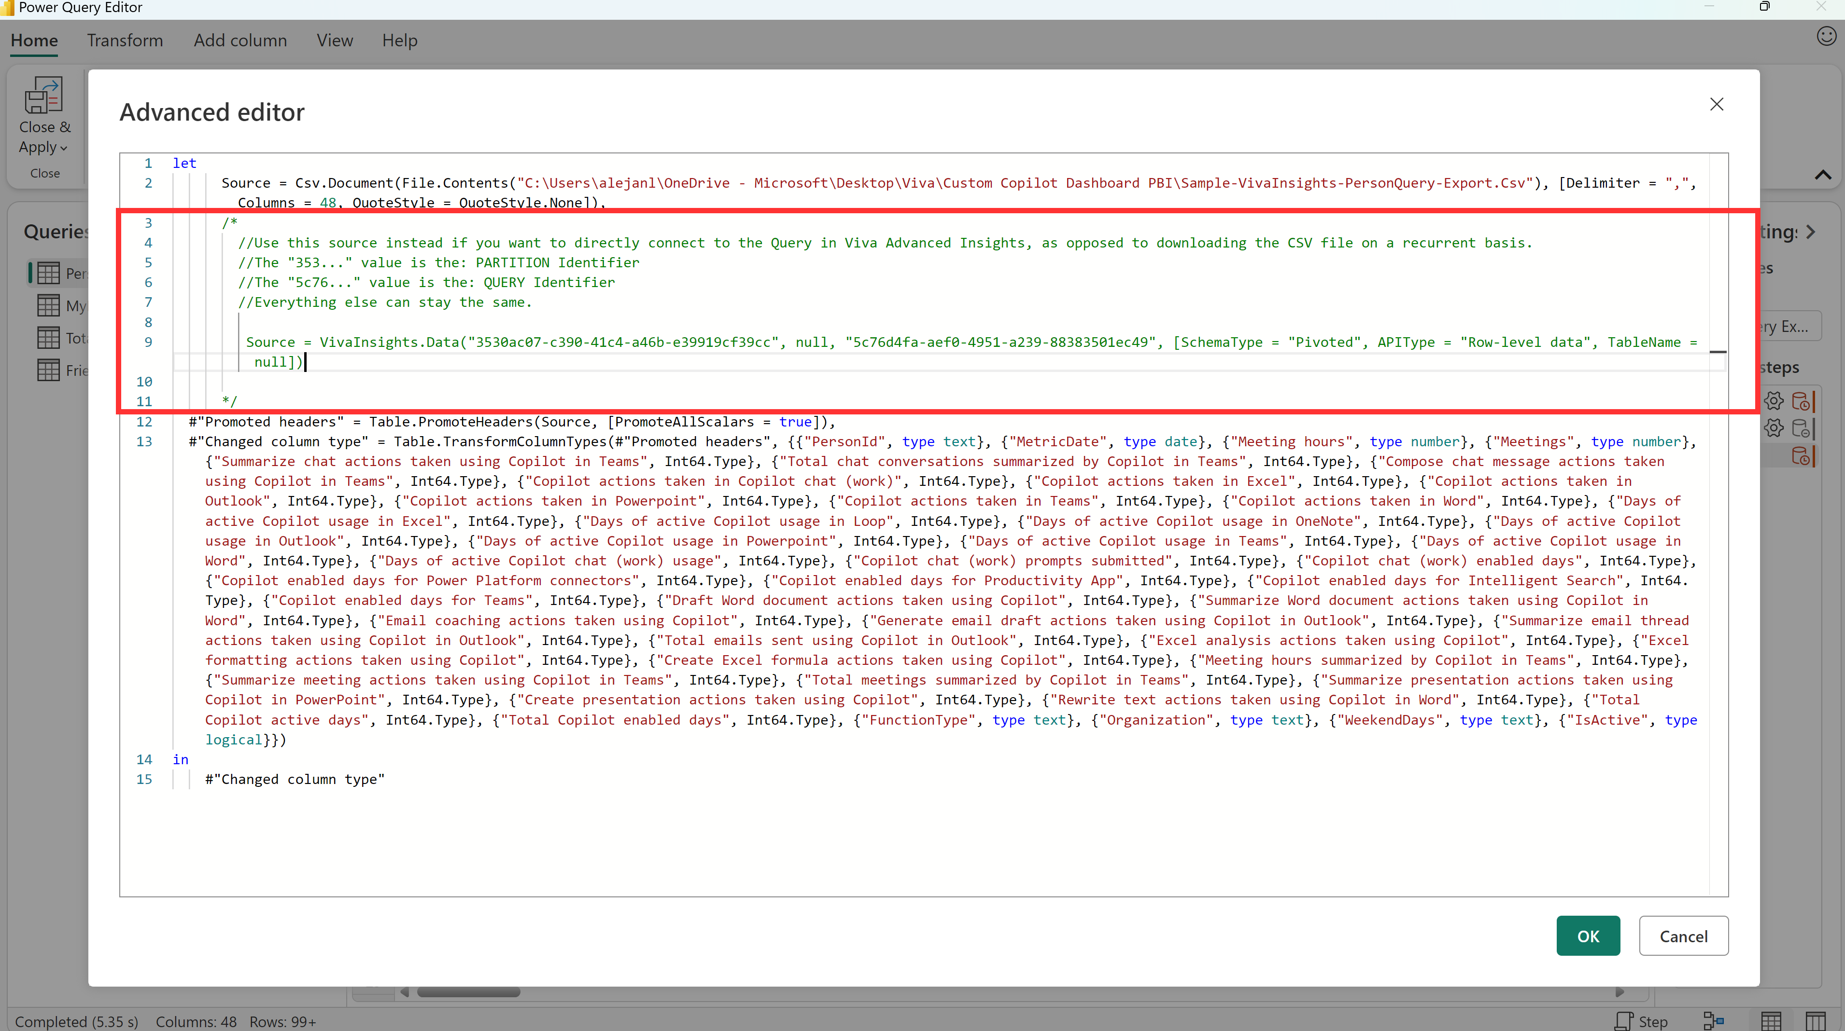

|  |
| --- |
| 🏷️**Note**: The partition identifier & query identifier can be grabbed from your “Query results” page in the Analyst Workbench. Click on **link** and you’ll see the identifiers in a popup. |

* 1. Next step is to **update the column names in the query to match the “Metrics” and the “Attributes”** that you added at the beginning in the creation of your query.
  2. A screenshot of a computer

     Description automatically generated

|  |
| --- |
| 🏷️**Note**: There’s a sample CSV export included in the Github repo so that you can more easily see which column names are being referenced by default in the PowerBI file. |

1. **Customizing the Report:**
   1. Once the template is loaded with the data, you can customize the report by adding or modifying visuals, filters, and other report elements as needed.
2. **Saving and Sharing the Report:**
   1. After customizing the report, you can save the Power BI report file (*.pbix) and also publish it as a report that can be shared with others, or by distributing the *.pbix file directly.